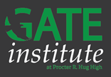
September 2016

Coordinator’s Corner
With Judith Mansfield, GATE High School Coordinator
Welcome to the 2016-2017 school year! We are off to an exciting start with the largest cohort of GATE scholars and teachers working through either their endorsement training or participating in focused GT training. In August I had the opportunity to present GT characteristics, instructional strategies for differentiation and resources for support to the entire staff. In addition to working with teachers one on one this year, I will also have the opportunity to participate in staff professional development with a series of presentations. In fact, I surveyed GATE scholars in preparation for my presentation and would like to share a few quotes from that survey.
“My time at Hug has been amazing. I honestly don't think I could be happy anywhere else after going here, everything is working out (college classes especially) and when comparing it directly to General Ed and IB, I am extremely grateful for this program and am really glad I didn't go anywhere else.”
“I am really loving this program. I am more than on board to continue this for the 4 years of high school. All the teachers are great. The campus is so friendly. I can't believe how Hug has its stigma when I feel so safe at school. Even in its early years. This experience is amazing.”
“This unique experience has allowed me opportunities that no other school would offer. The teachers are wonderful and are always there on your side and the students are so unique and diverse that it is impossible not to like this program.”
“My experience has been amazing because my schedule is so personalized and the teachers care about the students on an individual basis.”
Both our GATE scholars and I feel very fortunate to work with a staff who is open, willing and excited to teach these young learners. Isn’t that fantastic?

Resources for Students and Families
With anything new however, there is often a “honeymoon phase,” and with freshmen new to The GATE Institute this is definitely true. Scholars have stepped up to the challenge of advanced course work in a high school setting, and many jumped right into as many clubs and extra-curricular activities as they could possibly handle. In fact, some jumped into more than they could handle. As fall break nears to rescue these over-committers, try to talk with your young learner about setting priorities, managing time, working efficiently and balancing their lives with time for fun. That’s difficult for us to do as adults; isn’t it? Remember the apple doesn’t fall far from the tree, so this might be a good time to reflect together. Here are a few resources to assist you:
- 10 Important Study Habit Dr. Richard Cash provides a practical guide for creating successful study habit and managing study time. Students read this one!!
- Tips for Parents: Teaching Cheetahs to Hunt: Practical strategies for teaching executive functioning and academic skills for gifted and twice-exceptional kids This Tips for Parents article is from a seminar hosted by Aimee Yermish, an educational therapist specializing in work with children who are gifted, learning-disabled, or twice-exceptional. She discusses the transition from “child prodigy” to “eminent adult” and why it is not always an easy transition for gifted students.
- Tips for Parents: Real Life Habits for Success: The Way to Set & Achieve Your Goals: This Tips for Parents article is from a seminar hosted by Juli Scala, who provides advice on setting and achieving goals.
- Tips for Parents: Sleeping and Learning This Tips for Parents article is from a seminar hosted by Melissa Burnham, who discusses the importance of sleep and its impact on student learning, memory, and performance.

Social Emotional Learning

With Molly Ivans, GATE High School Counselor
This semester I am excited to be offering a 4 seminar series to address the social-emotional needs of our GATE Institute students. Topics will include:
- What Does It Mean to be Gifted? Myths vs. Truths (September)
- Executive Functioning Strategies and Skills (October)
- Growth Mindset (November)
- Perfectionism (December)
I am excited to be back in the classroom at Hug and looking forward to another great year! Also, I want to let you know that our GATE counseling team will be offering a Parent University class on perfectionism this fall. Please stay tuned for the date and time! Cheers to a brand new school year!

English

With John Kocian
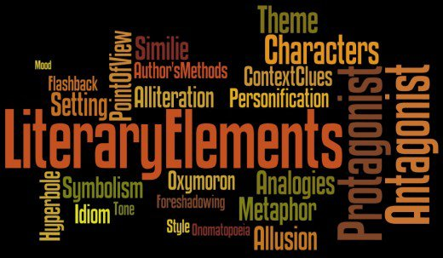
Things are moving right along in the English departments. While we are covering a great deal of good material, students are welcome to use internet or text resources to supplement the classwork. In AP Language we are investigating how rhetorical situation can inform argument and persuasion and beginning to practice writing argumentative essays. Students in Accelerated English 1-4 have been learning the essential literary terms necessary to analyze literature, specifically short fiction. We are preparing to launch our “Short-Story Bootcamp,” which will include student presentations of individual short stories. I am continually impressed with our students’ efforts and level of preparedness.

History:

AP US History with Janet Roberts
This past week our APUSH students completed their Middle Passage Project. The students choose to focus on either: Enslaved Rebellion, Enslaved Life, Laws/Acts and Supreme Court Cases, triangle of trade, and Enslaved Family Life. In peer groups they created or researched artifacts that explained the topic. I was so very excited and proud to see what they came up with. While every week you can expect your scholar to outline the chapter and take care of their key terms and people of importance, you can also expect what they do with that information once they arrive in my room to always be changing. What I love about history is the change. Although an event may have occurred hundreds of years ago, we can change the lens through which we view it and as a result better understand our past. As the kids are learning I hope they are finding that history is more about the unsung heroes, the everyday Joe and Joannas that make up the fabric of our nation and not simply the major dates and figures.

AP European History with Selena LeRue
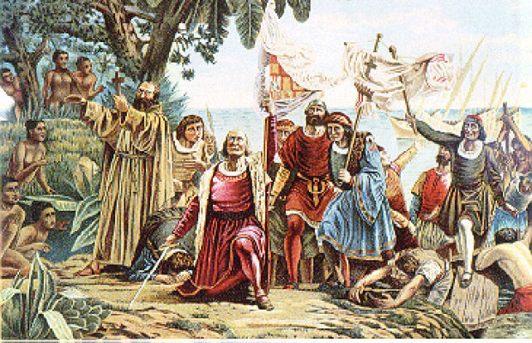
We are moving through time in AP Euro. We started with the 1300s and the Middle Ages and we’re currently discussing Columbus and the exploration of the 1500s and 1600s. Looking at the math, we’re covering almost 100 years every week! This means that the workload on our kids is definitely on the higher end, but our wonderful students have definitely shown themselves to be up to the task. Each week these kiddos read one chapter in the textbook, with reading notes, and complete about 30-50 vocab words for that time period. AP Euro is a content dense class (and test), but we are finding ways of making it fun. Last week, the students completed a “speed dating” activity about the Protestant Reformation. They each researched and personified a specific religious denomination of the time period and interviewed each other to find the perfect match between denominations. It was a kick! This activity exemplifies our class: we have serious work to do, but there is no reason we can’t enjoy the process of learning and growing.

Math:
Integrated IV with Bryce Baringer
In Integrated IV, we have completed the first two review units on piece-wise, absolute value, and inverse functions and are currently making our way through matrices and matrix operations. We’re learning what a matrix is, how they are used, and how to do basic to more complex operations involving matrices.
AP Calc BC with Arthur Pacheco
In AP Calc BC we have completed the 1st 5 sections on finding derivatives using the definition and are now using shortcut methods to find derivatives. We are interpreting the values of derivatives at different times and using these derivatives to predict the rate of change of a function at a specific point. We’re keeping up the pace. I thought it would be hard to stay on schedule but everyone seems to be ready to learn a new section each day. Not only are the students keeping up with the rather fast pace, some are asking questions to get a deeper understanding of what we are doing without knowing these topics will come up in the next section. It’s awesome.

Fine Arts:
AP Art Studio with Jen Johansen
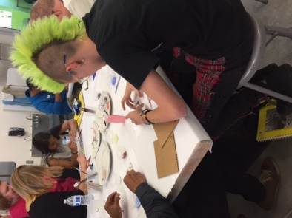
We started The Stranger Show preparation September 5th, at the Nevada Museum of Art. 19 students met artists from Reno, and began to collaborate on a piece together that will celebrate their identities and cultures and community. The show will be on Friday, October 14th from 6-8pm at the Holland Project on Vesta Street, across from Rapscallions.

Don't miss it! Put it on your calendar now!

Language:
German with Lori Breuch
German 1 students will be starting webquests on German fashion. German 3 Students are wrapping a unit on friendship. We will begin a student choice unit on sports in German speaking countries.

Clubs

Mock Trial with Selena LeRue
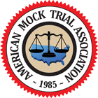
Our Mock Trial team is gearing up for a new season! We’ve got a strong, but small, team this year and we’d love to grow our program. Mock Trial is a club which meets after school on Wednesdays from 2-4 every week in C-18. From now until February we will be studying a legal case and building our own case to present to a judge at a (mock) trial. We focus on research skills, public speaking, thinking on your feet, and building a strong argument. Additionally, it is a great way to build connections with community leaders (such as judges and attorneys) and looks great on college applications and resumes. This is a perfect club for GT students because it plays to a lot of GT strengths and helps those who are college bound. If you are interested, please stop by C-18 any time for information or join us for our next meeting!

MESA with Pablo Aguirre
http://www.unr.edu/engineering/research-and-outreach/k-12-outreach/mesa MESA, or Mathematics, Engineering, Science Achievement, is a nationwide college-preparation program that strives to increase college enrollment among minority, low-income and first-generation college students. MESA promotes a strong academic foundation in mathematics and science as the key to college admission and success. We would love for GATE scholars to join MESA, the Engineering club. We build stuff! We compete! We go on field trips! If you want to build, have access to tutoring in math and science, learn about and visit UNR, then join us after school in B13. Our meetings are on Tuesdays from 2:45 – 4:45 PM in B13.

National Honor’s Society with John Kocian https://www.nhs.us/parents
The National Honor Society transcends American education and life. Since 1921, NHS has been recognizing the highest achieving students in grades 10-12. Today NHS inducts more than 1 million members each year who make significant service contributions to their schools and communities. NHS has become a springboard for life for successful individuals—from public servants, to media luminaries, to Supreme Court justices, to sports legends. Look for exciting announcements in our October issue!

The French and German Club with Lori Breuch
We are creating fundraising plans for decorating the world language hallway and a field trip to Bavarian World (restaurant). We are looking for sponsors.

